Prism Central Storage Configuration Items

Let’s use PC to perform a basic container setup

1. From the side bar menu (if it is not visible, click on the hamburger icon in the upper left corner. Select Compute & Storage and then Storage Containers (OR Type “Storage Containers” in the search box and select “Storage Containers -> List”)

1. Click the “Create Storage Container Button”
2. Give your storage container a name (Initials-Container) and select a cluster to create the storage container on.
3. Click on Advanced Settings and set the Advertised size to 500GB
4. Confirm that Compression is enabled and Compression type is set to Inline

1. Clicking Create in a moment you should see your container show up in the list. You can filter this list by name in the search bar above the list (a common feature you’ll find throughout the interface)

The storage container is now instantly available across all nodes within the cluster.

You can create multiple containers with different policies, all sharing capacity from the **Storage Pool**. For example, you may want to enable [deduplicationopen in new window](https://www.nutanixbible.com/4c-book-of-aos-dsf.html" \l "capacity-optimization" \t "_blank) for a storage container used for full clone persistent virtual desktops. However, deduplication wouldn't make sense for workloads such as databases. Similarly, you may want to create a storage container with [erasure codingopen in new window](https://www.nutanixbible.com/4c-book-of-aos-dsf.html#capacity-optimization) enabled for archival data, such as backups or security footage.

1. Explore the configuration basics further by updating your Container configuration. How would you ensure capacity availability for critical VMs on a cluster running mixed workloads?
2. Click on the name of a storage container that already contains data to drill down into the specific information about a given container. You can see the summary of the container, but also by clicking on the tabs above you can see container level alerts, events, performance metrics, and storage usage over time.

Again, these are common workflows you will see throughout the Prism Central Interface, whether you are reviewing storage containers, VMs, etc.

**Replication Factor (RF)**

The Nutanix platform currently uses replication factor (RF), and checksum to ensure data redundancy and availability in the case of a node or disk failure or corruption. RF sets the number of data copies to maintain (2 or 3). A replication factor of 3 adds an extra layer of data protection at the cost of storage an additional data copy.

Block Awareness ensures that secondary copies of data are not written to a node within the same physical enclosure as the primary copy. Block Awareness allows for the loss of a multi-node block without experiencing data unavailability. The same concept can be applied using a Nutanix cluster spanning multiple racks.

The basic requirement for rack/block fault tolerance is to have a minimum of 3 blocks in the cluster (for RF2) as we need to store three copies of metadata. Rack and block awareness can be supported with erasure coding enabled.

1. From the sidebar, click on Hardware and Clusters (OR TYPE “Clusters” and select “Clusters->List” in the search bar)
2. A screenshot of a computer

   Description automatically generated
3. Click on the name of your cluster
4. Click on “OK” in the Data Resiliency Status

Data Resiliency Status indicates how many failures can be tolerated without impacting the cluster. Each service listed has a specific function in the cluster. For example, Zookeeper nodes maintain configuration data (service states, IPs, host information, etc.) for the cluster.

The Redundancy State of a Cluster can be managed by selecting the Cluster under the Hardware section, clicking the “More” dropdown and selecting “Manage Redundancy State”

1. The RF of a cluster in PE can be configured by clicking **Redundancy State** in the  menu. An RF2 cluster can be upgraded to support RF3 (which requires a minimum of 5 nodes), or downgraded to RF1 with the following caveat:
2. **Warning**
3. Enabling RF1 does not guarantee data availability. Nutanix recommends enabling RF1 when your primary cluster use case is running applications that do not require storage resiliency. Enablign RF1 must be done at the Prism Element level.

**Takeaways**

1. The Distributed Storage Fabric provides RF2 or RF3 shared storage to the cluster.
2. Storage Containers allow you to define storage policy for VMs, including RF level, compression, deduplication, and erasure coding.

**Network Configuration**

**Overview**

In this section, you will learn how to set up a network. The networks you create in the steps below provide VMs with connectivity by assigning the appropriate networks to the VM's respective virtual network interface cards (NICs).

[#](https://bootcamps.nutanix.com/aos-on-ahv/network_configuration/network_configuration.html#ahv-networking-background)**AHV Networking Background**

Nutanix's Acropolis Hypervisor (AHV) leverages Open vSwitch (OVS) for all VM networking. OVS is an open-source software switch designed to work in a multi-server virtualization environment. Each AHV server maintains an OVS instance, and all OVS instances combine to form a single logical switch.

Each node is typically uplinked to a physical switch to multiple virtual LANs (VLANs), exposed as virtual networks.

VM networking is configured through Prism (or optionally CLI/REST), making network management in AHV very simple.

With AHV, you can also set up a DHCP server to automatically provide IP addresses for VMs on that network using the IP address management (IPAM) service. IPAM can potentially make network management more straightforward, as you wouldn't have to set up a separate DHCP server for the network.

Additional details about AHV networking can be found [hereopen in new window](https://www.nutanixbible.com/5a-book-of-ahv-architecture.html" \l "networking" \t "_blank).

[#](https://bootcamps.nutanix.com/aos-on-ahv/network_configuration/network_configuration.html#virtual-networks)**Virtual Networks**

* Similar to a VMware distributed port group.
* Each virtual NIC belongs to precisely one virtual network.
* Each virtual network is a common point of configuration for a group of vNICs.
* Physical switch port must be configured to trunk VLAN.

[#](https://bootcamps.nutanix.com/aos-on-ahv/network_configuration/network_configuration.html#virtual-nics-of-vms)**Virtual NICs of VMs**

* Each vNIC belongs to exactly one virtual network.
* For IPAM-enabled networks, vNICs get life-long static IP assignments.
* User may configure pools to allocate IPs, either automatically or by specifying the IP manually.

[#](https://bootcamps.nutanix.com/aos-on-ahv/network_configuration/network_configuration.html#ip-address-management-ipam)**IP Address Management (IPAM)**

* Integrated DHCP Server.
* AHV intercepts DHCP requests from guests on IPAM networks, and injects responses.
* Virtualization admin manages a range of IP addresses.
* Supports DHCP options, with UI support for DNS and TFTP configuration.

**Configure Network**

In the following exercise, you will create networks using invalid VLANs, meaning no VM traffic will be transmitted outside an individual host. This behavior is expected for demonstration/education purposes only.

**Create a Subnet without IPAM – TODO BASIC and NON-BASIC VLAN CONFIGS**

**We’re going to create a new subnet/network in Prism Central. You may use any VLAN ID \*other\* than 0. And do NOT enable IPAM**

1. From the sidebar, click on Network & Security and select “Subnets” (Or just search “Subnets” in the search field)

1. Click the blue “Create Subnet Button”
2. Enter the name for your subnet (Often this will be something like VLAN###, or an identifier that you will find applies to yoru environment). In this case name it “Initials-network”
3. Select the type as “VLAN”
4. Select the Cluster
5. Enter the VLAN ID, a value < 4096 other than your pRimary or Secondary network VLANs
6. Leave the Virtual switch the default
7. DO NOT select Enable IP Address Management
8. Click Create

Note that this is where one would create Overlay Networks used for VPCs and you can also select which virtual switch that one would want this VLAN to be assigned to. A VLAN ID can only be configured on a single virtual switch to avoid accidentially bridging DMZ networks.

**Create a Subnet with IPAM**

1. **Click on the “Create subnet button”**

* **Subnet Name** - Initials-Network\_IPAM
* **VLAN ID** - A value (< 4096) other than your Primary\* or Secondary network VLANs
* Select **Enable IP Address Management**
* **Network IP Address / Prefix Length** - 10.0.0.0/24
* **Gateway** - 10.0.0.1
* **Create Pool** - 10.0.0.100-10.0.0.150
  + **Be sure to click the blue checkbox when creating the pool range**
  + **Multiple valid ranges can be added to this box**
* Do not select Override DHCP Server

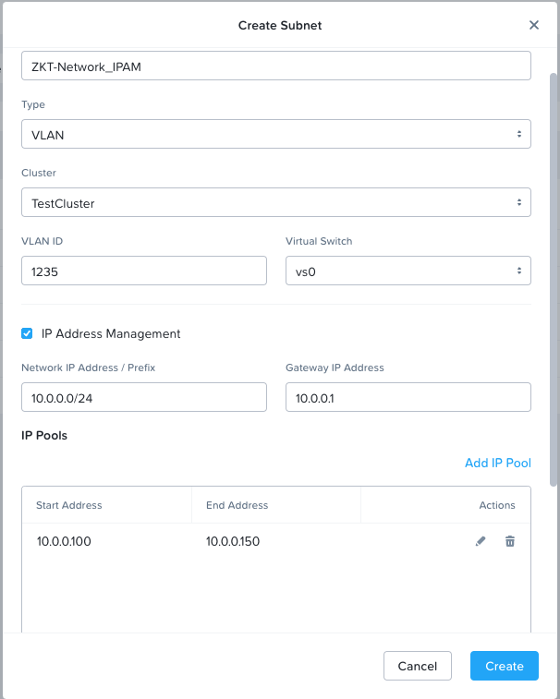

Note you will see a dropdown for “Domain Settings’. There is where you would add DNS servers, domain search information, and if you were using IPAM to support PXE booting, you could provide the TFTP Server name and boot file information, For our case we’re going to leave these items blank.

Click Create to build out the network.

The configured virtual network will now be available across all nodes within the cluster. VMs with vNICs on this network will receive a DHCP address from the range specified. This IP assignment lasts for the life of the VM, avoiding the need to depend on DHCP reservations or static IPs for many workloads.

**Takeaways**

* **It's effortless to set up a network in the cluster to establish VM connectivity.**
* **IPAM is very simple to set up within a network, and it can significantly simplify IP management within the cluster.**

**Deploying Workloads**

**Overview**

In addition to storage, VM creation, management, and monitoring can all be performed for Nutanix AHV directly through Prism. Prism also offers native support for VM CRUD (create, read, update, delete) operations for Nutanix clusters running ESXi.

In the following exercise, we'll create VMs from source media and existing disk images.

**Creating a Windows VM**

You will now create a Windows Server VM from a Windows installation ISO image.

AHV provides an Image Service feature to build a store of imported ISO or disk image files. The Image Service supports raw, vhd, vhdx, vmdk, vdi, iso, and qcow2 disk formats.

**Note**

You can explore the available images and upload additional images under “Compute & Storage -> Images” or by searching “Images” in the search bar.

To provide high-performance IO to VMs, AHV requires installing paravirtualized drivers into the guest (similar to VMware Tools). For Windows guests specifically, these drivers must be loaded during installation for the VM's disk to be accessible by the Windows installer. There are many options to add these to your default ISO such as slipstreaming or using tools such as packer, or they can be built into a gold image that is then sysprepped.

Nutanix validates and distributes these drivers via the [Nutanix Portalopen in new window](http://portal.nutanix.com/). The ISO image containing the drivers has already been uploaded to the Image Service.

1. From the Sidebar, select “Compute & Storage -> VMs” or search “VMs” in the search bar and selecting “VMs -> List”

1. Click the Blue “Create VM” button to launch the create VM wizard
2. Fill out the following fields
   1. Name – Initials-WindowsVM
   2. Cluster - <Select yoru clusters>
   3. CPU -> 2
   4. Core per CPU -> 1
   5. Memory -> 8GB
   6. A screenshot of a computer

      Description automatically generated
3. Click Next to to to the Resources tab
4. Under Resources click the “Attach Disk” button
5. Select the following
   1. Type -> CD-ROM  
      Operation -> Clone From Image  
      Image -> Windows Server
   2. Click Save  
      A screenshot of a computer

      Description automatically generated
   3. This will attach the Windows Server iSO to the VM
6. Click the Blue “Attach Disk” link above where your CDROM has now appeared
7. Select the following
   1. Type -> Disk  
      Operation -> Allocate on Storage Container  
      Storage Container -> The Container you created earlier  
      Capacity -> 30GB  
      Bus Type -> SCSI
   2. Click “Save”  
      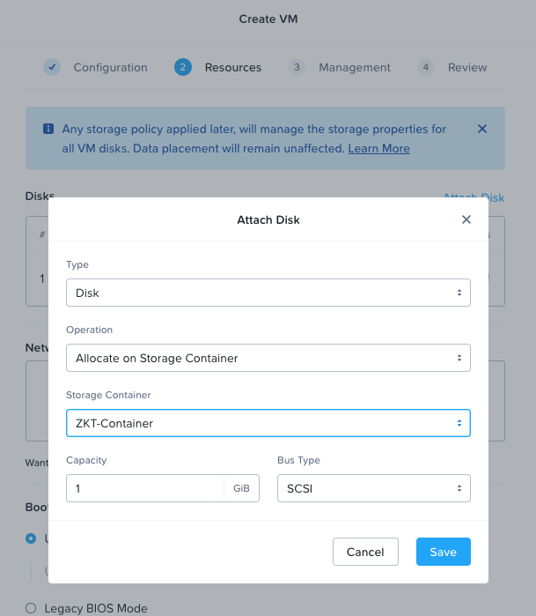
   3. This will create a 30GiB vDisk in the container
8. Once again click the “Add Disk” link
9. Select the following
   1. Type -> CD-ROM  
      Operation -> Clone From Image  
      Image -> VirtIO
   2. Click Save A screenshot of a computer

      Description automatically generated
   3. This attaches the VirtIO driver CD which we will use during installation
10. Click the “Attach to Subnet” Button
11. Select the following
    1. Vlan -> Initials->Network
    2. Network Connection State -> Connected
    3. Attachment Type -> Access
       1. Note we can create Trunk ports for specialized networking devices that may need multiple VLAN access
    4. Click Save A screenshot of a computer

       Description automatically generated
12. We will be building our VM in UEFI BIOS mode, however you can select UEFI or Legacy based on yoru eneds.
13. Click the blue “Next” button to move to Management
14. We are not doing any customization or assigning any categories at this time, so we can just click Next again on the Management Tab
15. At Review, scroll through and validate your VM configuration, the clieck “Create VM”
    1. Note if you made a mistake in any section, you can simply clik the “Edit” button aligned with that section to right back to the tab that covers it.
16. You should now see your VM in the list of Virtual Machines, you can use the filter bar at the top if you want to locate it in the list.
17. Right click on your VM and click “Power On”
    1. A screenshot of a computer

       Description automatically generated
18. After a few moments, the VM will start up and the Red dot will turn Green.
19. After a few moments, right click on yoru VM and select “Launch Console” from the list of actions to access the HTML5 console, allowing you to interact with the VM.
20. Progress through the standard install questions until you reach the Windows install location.
21. Choose **I don't have a license key**, **Windows Server 2019 Datacenter (Desktop Experience)**, and **Custom** installation when presented with the choice.
22. Click **Load Driver**, and navigate to the CD where the Nutanix VirtIO ISO is mounted.
23. Select the directory that corresponds to the Windows 2019.
24. A screenshot of a computer

    Description automatically generated
25. Select the three Nutanix drivers displayed. Press and hold the **Ctrl** key to select all three drivers: Balloon, Ethernet adapter, and SCSI passthrough controller.
26. A blue rectangular sign with white text

    Description automatically generated
27. Click **Next**.
28. After the drivers are loaded, the disk created in step 2 appears as an installation target.
29. Select that disk, and continue with the normal install process.

**Installing Nutanix Guest Tools**

1. **NGT is not a requirement, for all VMs, all the drivers are included in the VirtIO, however NGT provides the ability for backup tools and replication tools within Nutanix to leverage VSS and execute scripts to change IP addresses during DR scenarios.**
2. **NGT can be deployed from within Prism Central, or it can be separately downloaded as an MSI installer and silently deployed using your tool of choice.**
3. **To deploy from Prism Central, right click on the VM and select “Install NGT” and fill out the form as shown below**

1. Click on Confirm & Enter Password
2. If you have a local administrator user and password you can enter it here, for our purposes, as our VMs are not on a real network and won’t have WinRM access, we’re going to manually deploy it so simply click on “Skip and Mount”
3. Hop into the VM via the Console, log in via Administrator and install the Tools off of the CD.

**Creating a Linux VM**

You will now create a CentOS VM from an existing, pre-installed disk image in the Image Service. It is common in many environments to have template-style images of pre-installed operating systems. Similar to the previous exercise, the disk image has already been uploaded to the Image Service.

1. Click the Blue “Create VM” button to launch the create VM wizard
2. Fill out the following fields and click **Save**:
   * **Name** - Initials-Linux
   * **vCPU(s)** - 1
   * **Memory** - 2 GiB
   * Click Attach Disk
   * **Type** - DISK
   * **Operation** - Clone from Image Service
   * **Image** - CentOS7.qcow2
   * Select **Save**
   * Click Attach to Subnet
   * **VLAN Name** - Initials-Network
   * Select **Save** This will add a single virtual NIC to the VM on the selected Virtual Network.
3. Click “Next” Twice, and the “Create VM”
4. (Optional) Power up the VM and review the deployment of the VM

[#](https://bootcamps.nutanix.com/aos-on-ahv/deploying_workloads/deploying_workloads.html#takeaways)**Takeaways**

* In this lab, you saw how simple it is to deploy either a Windows and Linux VM.
* The Image Configuration tool allows you to catalog available images used in VM deployments as needed and cover broad format support that includes raw, vhd, vhdx, vmdk, vdi, iso, and qcow2.